**Input Domain Coverage Testing**

1. Boundary Value Analysis: -
2. In this application we have 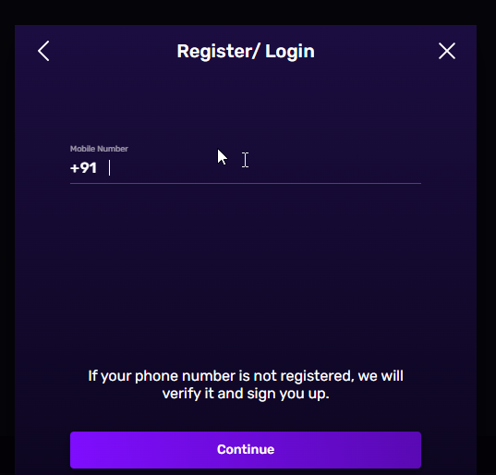 to enter mobile number for login.
3. In this application we can use email/mobile number.

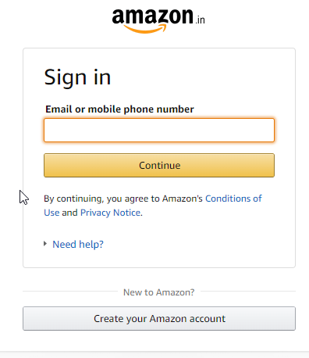

1. Equivalence Class Portioning: -
2. 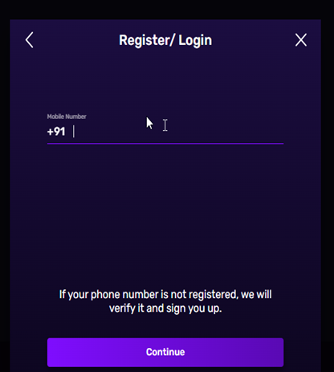In this application the upper and lower limit of number of digits is 10. Means the type of data is int.
3. 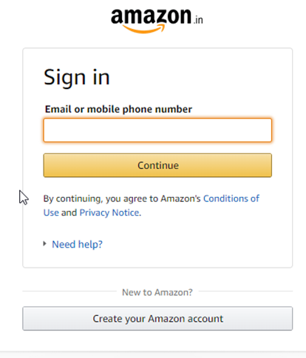In this application the type of data used is String.
4. 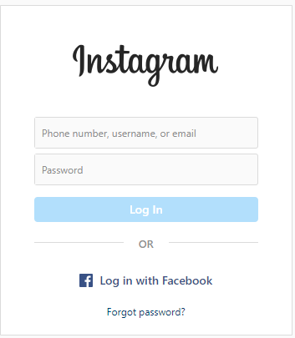 Decision Table Coverage Testing: -

|  |  |  |
| --- | --- | --- |
| ID | Password | Status |
| Valid | Valid | Sign in |
| Valid | Invalid | Check your password |
| Invalid | Valid | Check your ID |
| Invalid | Invalid | Check both ID and Password |